### **Scots on the Rocks**

### Moab Celtic Festival

### **October 17-19 2025**

**Vendor Application and Information**

### 

**Event Location - Moab City Ball Fields  
250 E Center St.   
Moab, UT 84532**

|  |
| --- |

**Application Deadline**: No Later Than September 30, 2025 (**Unless spaces fill earlier**)

The Moab Celtic Festival is an invitation only event. New vendors with items related to Scottish or Celtic culture are encouraged to apply. Your application must both be approved and payment received before your spot will be reserved. Due to limited space vendors are allotted space on a first come first served basis. Only a limited number of vendors selling each type of merchandise will be allowed. We reserve the right to reject any vendor for any reason at any time.

The vendor entrance fee is as follows:

* $170.00 for a 10x10 space
* $270.00 for a 10x20 space
* $320.00 for a 30x10 space
* $370.00 for a 20x20 space
* $320.00 for food vendors, specify booth size
* $10.00 for temporary business license for both food and merchandise vendors
* All booths include2 passes to the festival.
* Additional admission passes may be ordered with your application. Please reserve these no later than September 30, 2025. All extra passes NOT ordered in advance will have to be purchased at the gate.
* $35.00 will be charged on all returned checks and may disqualify you as a vendor.
* All fees are **Non-refundable**.
* Vendors are responsible for cleaning their own area after the festival. If your booth space is not cleaned by **10pm** **Sunday,** a $50 cleaning fee will be charged.
* Upon receipt of application form and fees confirmation will be forwarded to you. If possible, site maps will be sent out in advance. Passes and site maps will be available at check-in.
* A limited number of each type of merchandise vendor will be allowed at the festival.
* Limited electricity will be available, please indicate on the application.
* There is a noise ordinance in Moab. We need to clear the park by 10pm each night.

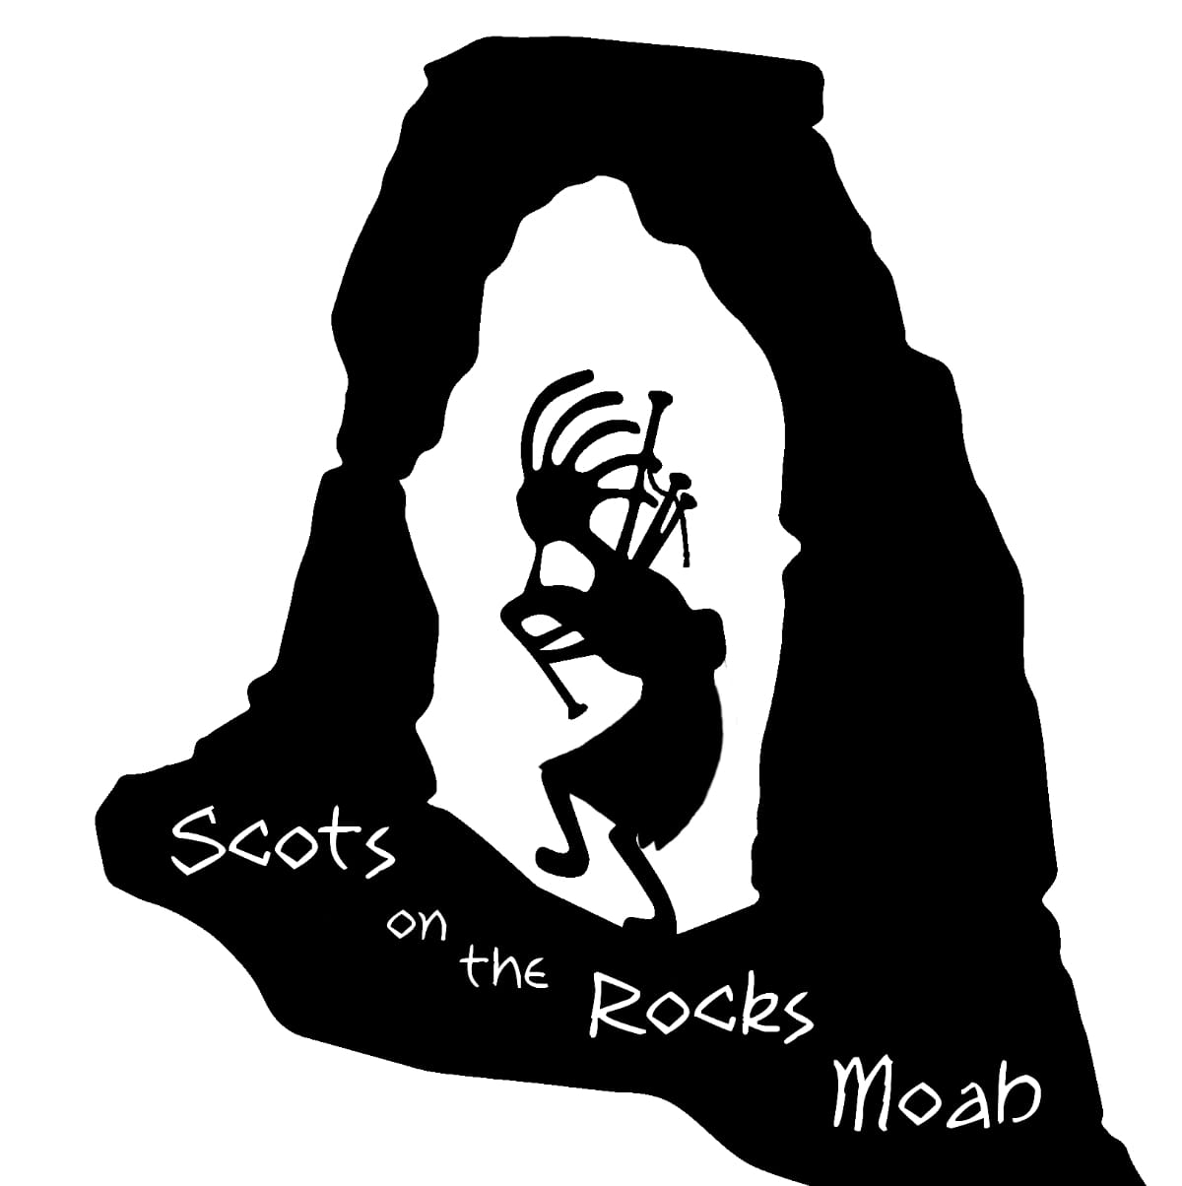

**VENDORS RESPONSIBILITIES DURING THE EVENT**

Vendors must be prepared to staff their space for the full duration of the Games. Leaving early, or arriving late will not be permitted and may jeopardize future participation in our event.

Cash flow is the responsibility of the vendor.

You may set up as early as 10:00 am on Friday. All vehicles must be parked or removed from the festival areas by 4pm on Friday. For the safety of our patrons and due to insurance reasons vendors will not be allowed to drive through the main pathways while the festival is open. Any violations of these restrictions may result in a ban from the festival in the future. Festival Hours are Friday 4-9pm, Saturday 9am-9pm and Sunday 9am-4pm.

____________

**Vendor Initials**

Vendors must provide their own table coverings and sun/rain/wind protection. Vendors assume full responsibility/liability for equipment, merchandise and other items they bring to the event.

Vendors are responsible for removing their garbage, failure to do so will result in a cleaning fee of $50 and may result in not being invited to future festivals.

No parking in loading/unloading area(s), you will be able to drive on the field. Vehicles must be moved once unloaded/loaded.

All Vendors must pay the $10 temporary license fee for the event. This fee goes to the city of Moab and we will print your temporary license and file it for you. If a license needs to be displayed then it will be delivered to your booth.

The Moab Celtic Festival is not responsible for any fines incurred by vendors for failure to comply with any and all licensing requirements.

Vendors must provide proof of insurance with the City of Moab listed on the policy. This needs to be sent with the application.

**Applications must be complete in order to be considered.**

**The Moab Celtic Festival Board of Directors reserves the sole right to allow/not allow any vendor at the festival for any reason.**

**Signature:_____________________________________ Date: ___________________**

**Scots on the Rocks presents**

**The Moab Celtic Festival**

**Vendor Application and Information**

**October 17-19 2025**

**Name of Business:______________________________________________________________**

**Contact Name:_________________________________________________________________**

**Address: _____________________________________________________**

**City: _________________________________ ST____________ Zip_______________**

**Phone #:___________________________ Email: ________________________________**

**Web Address or Facebook page (if you have one – we post this on our website)**

**___________________________________________________________________**

**Please provide a brief description of your products/services:**

**______________________________________________________________________________**

**______________________________________________________________________________**

**Please indicate the following vendor space requirements:**

**10’ X 10’ Vendor Space* @ $170.00 =________________**

**10’ X 20’ Vendor Space* @ $270.00 = ________________**

**20’ X 20’ Vendor Space* @ $370.00 = ________________**

**Food Vendors* (BOOTH SIZE________) @ $320.00= ________________**

**Temporary business license(required) @ $10.00=_________________**

**Chairs @ $5.00 = ________________**

**Tables @ $10.00 = ________________**

**Extra Passes @ $5.00 = _________________**

**Total Enclosed = __________________**

**\*All Booth Fees include 2 passes to the festival and a Cleaning fee of $50 may be charged if your site is not properly cleaned.**

**Do you need access to electricity for your booth during the festival? Sites are limited**

**___Yes**

**___No**



**Do you have any special needs or requests, please state them here. Understand that not all requests will be met due to the growing size of the festival and accessibility issues.**

**_______________________________________________________________________________________________________________________________________________________.**

# **Are you interested in being able to purchase ice at the event? _______________**

**Estimated Quantity of Ice Needed (20 lb. bags ) _________**

**I would be willing to donate prizes for the children's games?**

**I would be willing to donate items for door prizes/silent auction?**

**WAIVER:**

**I have read and understand the rules and regulations and wish to be a vendor at the Moab Celtic Festival (Scots on the Rocks). I hereby for myself, my heirs, executors, and assigns waive and release any and all rights and claims I may have for damages against the Moab Celtic Festival, its agents or representatives for any injuries which may be suffered by me during the Moab Celtic Festival (Scots on the Rocks) sponsored by said Association and/or any function related to the Gathering. By signing the contract I agree to have my photo taken. The photos will belong to the association and may be used for promotional activities including, but not limited to marketing videos and being posted on our website.**

**Signature:_____________________________________ Date: ____________________**

**Please mail application/payment to:**

**Scots on the Rocks Moab**

**Attn: Stephanie**

**1156 E Elgin Ave.**

**Salt Lake City, UT 84106  
  
We also accept online payment via Paypal or Venmo.**

**Paypal: moabcelticfestival@gmail.com**

**Venmo: Scots-Rocks**

**Any questions can be answered by at vendors.scotsontherocks@gmail.comor 801-652-4508 (Please leave a voicemail with your name and call back #)**

**www.scotsontherocksMoab.org**